Indraprastha Institute of Information Technology Delhi (IIITD) Department of Computational Biotechnology
BIO213 – Introduction to Quantitative Biology

Quiz-2_Rubrics (October 17, 2025)

Choose the correct answer for the following questions (1-12):
- Which algorithm is used to find the most likely path in an HMM? (1 mark)
a. Needleman–Wunsch
  - Smith–Waterman
  - Viterbi algorithm
  - BLAST algorithm

- The Prosite pattern [AC]-x-V-x(4)-{ED} matches which peptide? (2 marks)
  - CAVXNNNKF
  - AVVNNNNK
  - AKVAAAAG
  - AEVNNNNK

- In a DNA sequence logo, the maximum information possible per position is (2 marks)
a. 2 bits
  - 4 bits
  - 20 bits
  - 10 bits

- In hybridization mapping, the Consecutive Ones Property (C1P) model is solvable in linear time if: (1 mark)
a. Probes are unique and error-free
  - Probes can repeat with errors
  - Clones are circular
  - No two probes co-occur

- Which of the following statements about sequence logos is correct? (1 mark)
  - The height of each letter is proportional to its frequency only
  - The total height of a column reflects information content
  - All columns have the same total height
  - Sequence logos are not used for proteins

- The double digestion problem is NP-complete. What conceptual factor contributes to this complexity? (1 mark)
a. The requirement for unique probes.
  - The factorial number of permutations for restriction sites.
  - The use of sticky ends instead of blunt ends.
  - The linear time solution when lengths are distinct.

- Which of the following wrongly describes protein domains? (1 mark)
  - They are made up of one secondary structure
  - Defined as independently foldable units
  - They are stable structures as compared to motifs
  - They are separated by linker regions

- Even if many pseudocounts are added in comparison to real sequence counts, the amino acid frequencies will not have any effect or influence. (1 mark)
a. True
  - False

- What is iterated in PSI-BLAST? (1 mark)
a. PSSM
  - Z-score
  - E-value
  - Blastp with BLOSUM62

- In regular expressions, which of the following pair of patterns is wrongly matched with its significance? (1 mark)
a. ^ – anything but not
  - < - N terminal
  - > - C terminal
  - >> – end

- What does this representation mean - <A-x-[ST](2)-x(0,1)-V-{ED}? (2 marks)
  - C terminal- Ala-any-[Ser or Thr]-[Ser or Thr]-(any or none)-Val-{any except Glu or Asp}
  - N terminal-Ala-any-[Ser or Thr]-[Ser or Thr]-(any or none)-Val-{any except Glu or Asp}
  - C terminal- Ala-any-[Ser or Thr]-[Ser or Thr]-(any or none)-Val-{Glu or Asp}
  - N terminal-Ala-any-[Ser or Thr]-[Ser or Thr]-(any or none)-Val-{Glu or Asp}

- Which of the following is a correct stopping criterion for PSI-BLAST convergence? (1 mark)
  - No new sequences are added in the last iteration
  - E-value threshold is set to zero
  - All database sequences are included
  - The profile matrix is empty

Answer the following question:

- Given the following multiple sequence alignment with 5 residues at a certain position,
Protein 1: A
Protein 2: A
Protein 3: A
Protein 4: T
Protein 5: T Calculate:
  - Frequencies of A and T.
  - Shannon entropy (H).
  - Information content (I).
  - Which residue will appear taller in the sequence logo? Explain your reasoning. (5 marks)
Ans: We use the same observed column: 5 sequences with residues A, A, A, T, T → frequencies $f(A)=0.6, f(T)=0.4$.
First compute the Shannon entropy (bits) step-by-step:
- ${log⁡}_{2}(0.6)=\frac{\ln{0.6}}{\ln{2}}=\frac{-0.5108256238}{0.69314718056}=-0.7369655940$
$$0.6{log⁡}_{2}(0.6)=0.6×(-0.7369655940)=-0.4421793564$$
- ${log⁡}_{2}(0.4)=\frac{\ln{0.4}}{\ln{2}}=\frac{-0.9162907319}{0.69314718056}=-1.321928095$
$$0.4{log⁡}_{2}(0.4)=0.4×(-1.321928095)=-0.5287712380$$
- Sum and take negative:
$$H=-(-0.4421793564+(-0.5287712380))=-(-0.9709505944)=0.9709505944\text{ bits}$$
Nucleotide (DNA) case
Maximum uncertainty for DNA $={log⁡}_{2}(4)=2.0000000000$bits.
- Information content $I=2-H=2-0.9709505944=1.0290494056$bits.
Partition the column height among residues proportionally to frequency:
- Height(A) $=0.6×1.0290494056=0.6174296434$bits
- Height(T) $=0.4×1.0290494056=0.4116197622$bits
Interpretation: A is taller than T in the DNA sequence-logo column (A ≈ 0.6174 bits, T ≈ 0.4116 bits).
Protein (amino-acid) case
Maximum uncertainty for proteins (20 amino acids) $={log⁡}_{2}(20)=4.3219280949$bits.
- Information content $I=4.3219280949-H=4.3219280949-0.9709505944=3.3509775005$bits.
Partition among residues:
- Height(A) $=0.6×3.3509775005=2.0105865003$bits
- Height(T) $=0.4×3.3509775005=1.3403910002$bits
Interpretation: A is taller than T in the protein sequence-logo column too (A ≈ 2.0106 bits, T ≈ 1.3404 bits) because the observed frequencies are the same; the protein logo column is simply much taller overall because the alphabet is larger.

14. Find a solution given the following results of a double digest experiment. | (5 marks)
Enzyme A: 1000, 2100, 1400, 500
Enzyme B: 1200, 2500, 1300
Enzyme A+B: 1000, 200, 1900, 600, 800, 500?
Ans: Label the six A+B fragments (left → right) as $a,b,c,d,e,f$. From the single-enzyme sums we get:
From A:
- $a=1000$
- $b+c=2100$
- $d+e=1400$
- $f=500$
From B:
5. $a+b=1200$
6. $c+d=2500$
7. $e+f=1300$
Use (1) and (5) to get $b$. Use (4) and (7) to get $e$, then the remaining unknowns.
Step by step:
- From (1): $a=1000$.
- From (5): $a+b=1200⇒b=1200-1000=200.$
- From (2): $b+c=2100⇒c=2100-b=2100-200=1900.$
- From (6): $c+d=2500⇒d=2500-c=2500-1900=600.$
- From (4): $f=500$.
- From (7): $e+f=1300⇒e=1300-500=800.$
Check (3): $d+e=600+800=1400$
So the A+B fragments (in the solved order) are:
$$a=1000, b=200, c=1900, d=600, e=800, f=500$$
Total length $=1000+200+1900+600+800+500=5000$bp.

Physical map / cut positions
Take the AB fragments in that left→right order and compute cumulative positions (starting at 0):
Fragment lengths and cumulative coordinates:
- 0 → 1000 : $a$(1000)
- 1000 → 1200 : $b$(200)
- 1200 → 3100 : $c$(1900)
- 3100 → 3700 : $d$(600)
- 3700 → 4500 : $e$(800)
- 4500 → 5000 : $f$(500)
So cut positions (internal coordinates, 0..5000) are at:
after a: 1000, after b: 1200, after c: 3100, after d: 3700, after e: 4500, end: 5000

Now indicate enzyme cut boundaries:
- A fragments were: 1000, 2100, 1400, 500
Cuts (A boundaries) are at: 1000 (end of first A fragment),
1000+2100 = 3100,
3100+1400 = 4500 (then end at 5000).
So A cuts at positions 1000 and 3100 (internal), with final boundary at 4500 before last fragment.
- B fragments were: 1200, 2500, 1300
  - Cuts (B boundaries) are at:
1200 (end of first B fragment),
1200+2500 = 3700 (end of second),
then end at 5000.
So B cuts at positions 1200 and 3700.

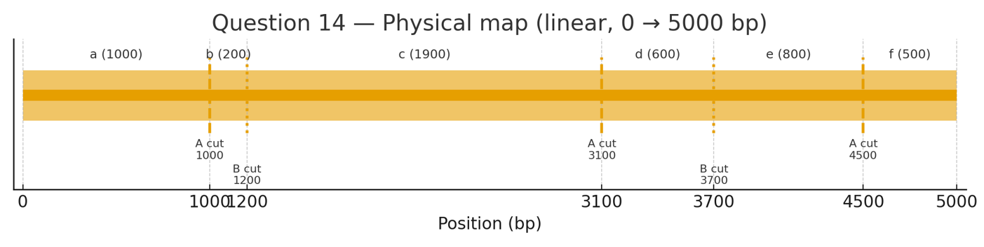

- Use the following information of fragment sizes obtained from an enhanced double digestion experiment using restriction enzymes A and B to create the physical map of DNA. (5 marks)
Ans: One consistent AB₁ fragment order (left → right) is:
6, 3, 12, 15, 8, 29, 17
Cumulative coordinates (kb):
0, 6, 9, 21, 36, 44, 73, 90
Grouping to obtain A fragments → 9, 12, 15, 37, 17
Grouping to obtain B fragments → 6, 38, 46
A-cut boundaries: 9, 21, 36, 73
B-cut boundaries: 6, 44
Total DNA length = 90 kb

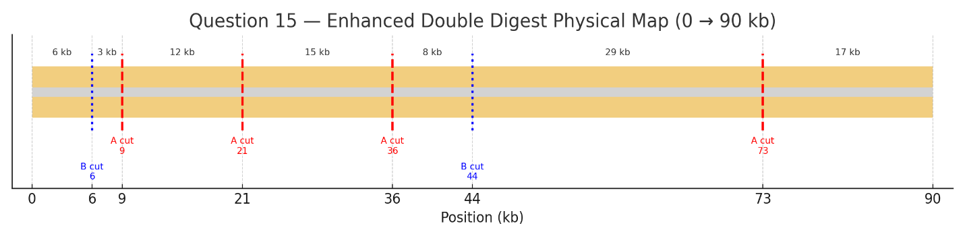

- You have a PSSM column with raw counts: A=0, C=4, G=1, T=0. Add pseudo-counts = 1 for
each base, and recalculate the corrected frequency of C. (2 marks)

Ans:
Base | Raw count | +1 pseudo | Corrected count
A | 0 | +1 | 1
C | 4 | +1 | 5
G | 1 | +1 | 2
T | 0 | +1 | 1

f(C)= corrected count/ total corrected count of C​=5/9​ ≈ 0.556
- If an HMM emits the sequence “ACG” with emission probabilities: P(A|M) = 0.4, P(C|M) = 0.3, P(G|M) = 0.2, and transition probability M → M = 0.8, find the probability of observing “ACG” under this model. (4 marks)

Ans: P (A, C, G) = P(A∣M) × P(M→M) × P(C∣M) × P(M→M) × P(G∣M)
P(A, C, G)=0.4×0.8×0.3×0.8×0.2
=0.01536

- In a hybridization mapping experiment, the binding (hybridization) of a set of DNA probes (P₁– P₅) to a set of clones (C₁–C₅) is recorded in the binary matrix below. A value of 1 indicates that
a probe hybridizes to a clone; 0 indicates no binding. (4 marks)

 | C1 | C2 | C3 | C4 | C5
P1 | 0 | 1 | 0 | 1 | 0
P2 | 1 | 0 | 0 | 1 | 1
P3 | 1 | 0 | 1 | 0 | 1
P4 | 1 | 1 | 0 | 1 | 0
P5 | 0 | 0 | 0 | 1 | 0

  - Explain the Consecutive Ones Property (C1P) in the context of hybridization mapping. Why is it biologically meaningful for ordering clones along a chromosome?
  - Using the matrix above, determine whether the current column (clone) order satisfies the Consecutive Ones Property for all probes. If not, propose an ordering of the clones that satisfies the C1P for all probes, assuming such an order exists.

Ans : (a) The Consecutive Ones Property (C1P) means that, in each probe (row), all the 1’s appear together in one continuous block when the clones (columns) are arranged in their correct physical order.
Biological meaning:
Each probe binds to a specific stretch of DNA sequence on the chromosome. Because clones represent overlapping segments of a continuous DNA region, a probe should hybridize to a contiguous set of clones along the chromosome. Therefore, when clones are correctly ordered according to their true physical position, every probe will show a single uninterrupted block of hybridization (1’s).

(b) In the given matrix:
 | C1 | C2 | C3 | C4 | C5
P1 | 0 | 1 | 0 | 1 | 0
P2 | 1 | 0 | 0 | 1 | 1
P3 | 1 | 0 | 1 | 0 | 1
P4 | 1 | 1 | 0 | 1 | 0
P5 | 0 | 0 | 0 | 1 | 0
The current column order (C1–C5) does not satisfy the Consecutive Ones Property, since several probes (P1, P2, P3, P4) have 1’s that are not contiguous.
A valid ordering of clones that satisfies the C1P for all probes is:
C2, C4, C1, C5, C3
(or its reverse order C3, C5, C1, C4, C2)

